Target Model: Llama-3.2-3B
Hardware Platform: NVIDIA GeForce RTX 3060 (Ampere architecture, SM 8.6)
This report provides a formal engineering teardown of the four core phases of your LLM engine's lifecycle, mapping your captured Nsight Systems high-level views to the hardware micro-architecture execution patterns.

🛠 Phase 1: Weight Loading & Host-to-Device Transfer

Timeline Visualization

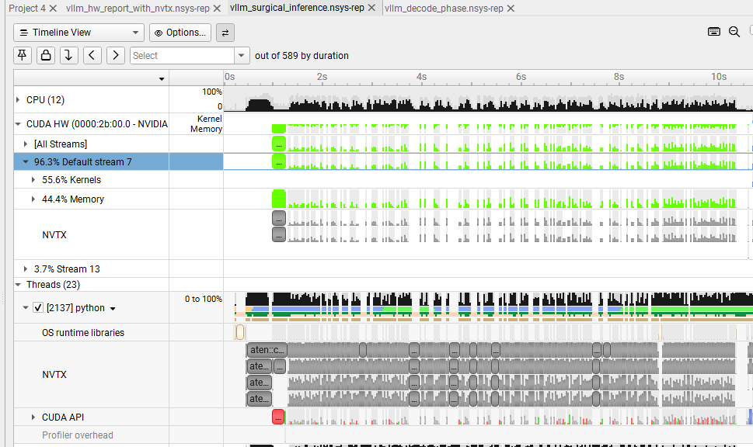

Technical Breakdown
- The Mechanism: The ~6 GB of model weights (FP16 representation for a 3B parameter model) are pulled from disk storage into CPU memory, then streamed across the PCIe bus into the GPU's VRAM.
- The Bottleneck: Because this process runs inside a Windows Subsystem for Linux (WSL) environment, the framework defaults to pin_memory=False. The host operating system must continuously allocate an intermediate, page-locked staging buffer, copy the weight pages into it, and then hand it off to the GPU’s Direct Memory Access (DMA) engine.
- The System Status: The Streaming Multiprocessors (SMs) are completely compute-starved. The Kernels track is empty, while the Memory track is saturated at $100\%$ utilization.

Phase 2: Warmup & Virtual Memory Allocation

Timeline Visualization
Captured in your zoomed-out trace window from 8.0s to 14.0s.
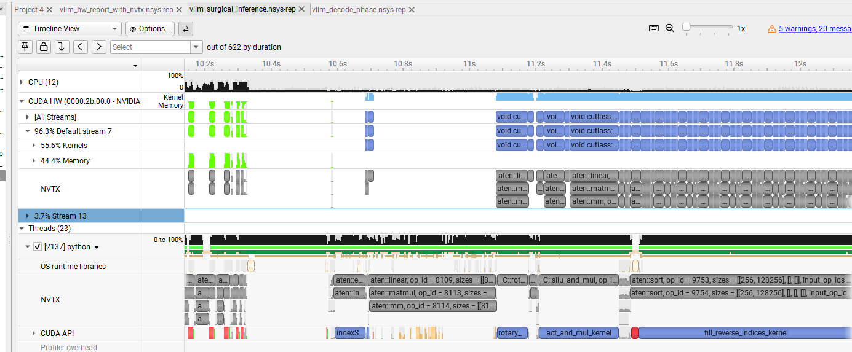

Technical Breakdown
- The Mechanism: Immediately following weight deployment, vLLM triggers a mock forward pass to gauge the exact memory headroom remaining in VRAM. It dynamically constructs the virtual paging blueprints required for PagedAttention.
- The Timeline Signatures:
  - aten::linear / aten::matmul: Framework-level PyTorch tensor operators orchestrating trial structural passes.
  - fill_reverse_indices_kernel: A long, structural CUDA API kernel execution blocking the timeline for over a second. This kernel is physically mapping the look-up indexes and page tracking tables in VRAM to manage KV Cache allocation without memory fragmentation.
- The System Status: This represents a mandatory "one-time engineering tax" used to establish memory boundaries. It is config-tuneable (via structural parameters like --gpu-memory-utilization) but cannot be code-optimized.
Graph anaylsis
• Left Boundary Start: 0.85s (Right where the green Memcpy block finishes and the massive wall of gray aten:: NVTX blocks begins).
• Right Boundary End: 11.2s (Where the vertical blue line is sitting on your screen—right after fill_reverse_indices_kernel finishes and the timeline goes completely blank before the prefill math starts at 12s).

- • The Core Rehearsal (0.85s to 10.5s): The solid block of gray stacked bars in the NVTX track shows PyTorch running its trial layers back-to-back to measure peak activation memory.
- • The Final Memory Mapping (10.5s to 11.2s): At the tail end of this block, you see the aten::sort NVTX block and the blue fill_reverse_indices_kernel bar executing. This is the exact moment vLLM finishes its rehearsal and builds the virtual memory block tables for your KV cache pages.

1. 10.5s – 11.0s: The Memory Profiling Forward Pass
- What's happening: Look at aten::linear (op_id=8109), rotary, and act_and_mul_kernel. This is the single mock forward pass vLLM runs to measure peak activation memory before allocating the KV cache.

2. 11.4s – 12.1s+: KV Cache Allocation (fill_reverse_indices_kernel)
- What's happening: Once the mock pass finishes, vLLM calculates exactly how much VRAM is left. It immediately launches fill_reverse_indices_kernel (accompanied by aten::sort) to carve up that remaining VRAM into block tables for your PagedAttention KV Cache.

3. 11.2s – 12.1s+ (Stream 7): CUDA Graph Capturing (The Repeating Blue Grid)
- What's happening: Look at the CUDA HW track on the top right. See those stacked, perfectly identical rows of blue blocks labeled void cu... and void cutlass...?
- This is the engine actively capturing and baking the CUDA Graphs for different token sequence lengths. It runs them in rapid-fire loops to save the execution blueprints so steady-state decoding can run without CPU overhead later.

Phase 3: The Prefill Phase (Prompt Ingestion)

Timeline Visualization
Captured in your close-up execution trace.
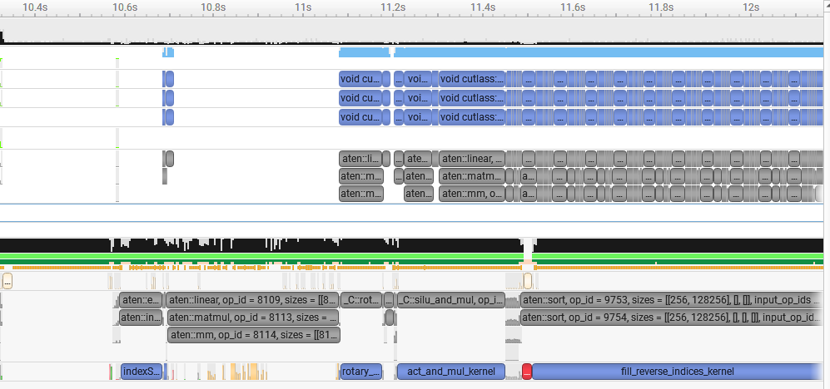

Technical Breakdown
- The Mechanism: A user prompt hits the engine. The system processes the incoming prompt tokens simultaneously, requiring massive matrix-matrix calculations to populate the initial attention states.
- The Timeline Signatures:
  - cutlass::Kernel2<cutlass_80_tensorop...>: Highly optimized GEMM (General Matrix Multiplication) execution running back-to-back directly on your hardware Tensor Cores.
  - vllm::rotary: Hardware kernels applying rotary positional embeddings (RoPE) to bind sequential context to the vectors.
  - flash_fwd_kernel: The execution of the FlashAttention framework, calculating scaled dot-product attention values with minimal VRAM round-trips.
- The System Status: Compute-Bound (Peak Saturation). The GPU cores are packed shoulder-to-shoulder with zero latency bubbles, indicating the CPU is queuing instructions perfectly.

Phase 4: The Autoregressive Decode Phase (Steady State)

Timeline Visualization
Captured in your surgical trace from 17 to24sec

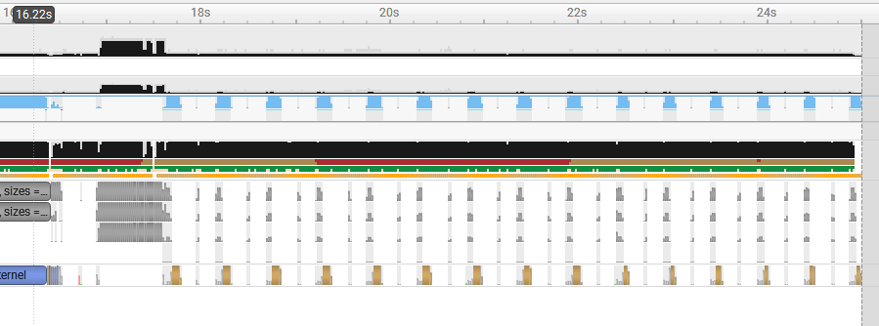

Technical Breakdown
- The Mechanism: The engine switches from a dense, parallel prompt processing layout to an iterative, token-by-token generation cycle. The model generates text one word at a time, transforming the processing profile from matrix-matrix calculations into matrix-vector equations.
- The Timeline Signatures:
  - The Rhythmic Pulse: Notice the thin, uniformly spaced vertical bars on your hardware track. Each pulse is a single token generation step.
  - cudaGraphLaunch: Instead of hundreds of independent cudaLaunchKernel calls creating severe CPU overhead gaps between words, vLLM plays back a pre-compiled execution graph. The CPU issues a single instruction block, and the GPU executes the sequence natively.
  - vllm::paged_attention_v2_kernel & cublasGemv: Lookups inside your custom block tables to pull the conversation history (KV Cache) forward to interact with the single new token vector.
- The System Status: Memory-Bandwidth Bound. Compute saturation drops because the Tensor Cores must constantly wait for individual weights to shift from VRAM cache lines into local registers for each single token.
Graph analysis
• The Token-by-Token Heartbeat (17.2s onward): Look at the CUDA HW row. The perfectly uniform, evenly spaced vertical blue bars represent the execution of individual tokens being decoded sequentially.
• Eliminated CPU Overheads: Notice how the NVTX and CUDA API tracks below those blue bars match the same exact pattern. The massive walls of cluttered gray stacks disappear completely, replaced by lean, structured spikes—a classic signature of optimized CUDA Graph playback handling steady-state generation.

Feature | Phase 1 (Loading) | Phase 2 (Warmup) | Phase 3 (Prefill) | Phase 4 (Decode)
Primary Driver | PCIe Bus / OS Copy | Framework Config | GPU Tensor Cores | VRAM Bandwidth
Limiting Factor | Host-to-Device Speeds | CPU Synchronization | Compute-Bound ($TFLOPs$) | Memory-Bound ($GB/s$)
Visual Pattern | Massive Green Blocks | High NVTX Stack Chaos | Solid Dense Blue Wall | Spaced, Rhythmic Spikes
Optimization Lever | Safetensors / Pinned Mem | Ahead-of-Time Comp | Kernel Fusion / TP | CUDA Graphs / FlashDecode

Project Summary: LLM Inference Optimization & Profiling

Toolstack Used
- Framework: vLLM (serving a Llama model architecture)
- Profiling Tools: NVIDIA Nsight Systems (nsys profile)
- Operating Environment: Windows Subsystem for Linux (WSL)
- Underlying Hardware Acceleration: CUDA, CUDA Graphs, FlashAttention Kernels

What You Have Done & Analyzed

1. Engine Bootstrapping & Lifecycle Analysis
You mapped out the timeline of how an enterprise LLM engine prepares for execution, successfully isolating distinct operational phases:
- Phase A (Memory Profiling): Analyzed how the engine runs early, un-cached trial forward passes using dense FlashAttention kernels to test GPU headroom.
- Phase B (KV Cache Allocation): Identified the exact moment the engine allocates its memory block manager via a massive, long-running cudaMemcpyAsync operation.
- Phase C (CUDA Graph Capture): Caught the specific transition sequence (cudaStreamBeginCapture $\rightarrow$ Vectorized Elementwise Kernels $\rightarrow$ Graph Blueprint Finalization) where the runtime records execution pathways to eradicate CPU launch overhead.

2. Hardware-Level Bottleneck Identification
You diagnosed runtime execution behaviors by reading micro-timelines down to individual hardware API tracks:
- Batch Size Scaling: Discovered that a small batch size (e.g., $1$) starves the GPU's Streaming Multiprocessors (SMs), making fixed CPU/PCIe overhead dominant. Increasing the batch size to $16$ successfully saturated the parallel architecture, masking latency and skyrocketing throughput from 42 to 479 tokens/s.
- Host-to-Device Memory Bottlenecks: Isolated the decoding phase signature on the timeline, identifying how ultra-fast GEMV (General Matrix-Vector) kernels are interrupted by red cudaMemcpyAsync blocks and beige OS ioctl driver calls as the system moves token data across the PCIe bus.

